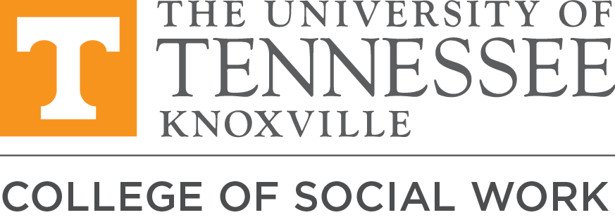

Field Instructors---

We are so excited to share our recorded version of our Field Instructor training with you! There are 10 videos that you can watch on your own time, including:

- Eight short videos giving an overview of field education at UT, ranging from 3-25 minutes (3 hours total including review of handouts)
- 1-hour training video on culturally sensitive practice in field
- 1-hour training video on ethics and field education
If you’ve recently been through our all-day training, you aren’t required to complete all of these but can pick and choose any that you’d like to watch. Module 1 contains some important updates that began in 2021. Additionally, the 2 hours on culturally sensitive practice in field education and ethics in field are fairly recent additions.

Once you complete the training, complete the online evaluation survey at https://utk.co1.qualtrics.com/jfe/form/SV_e9U6uLYScL46xH8, and within 2 weeks Hannah Collins (hbrown22@utk.edu) or Cassidy Hebert (chebert8@utk.edu) will email you a training certificate for up to 5 hours of training: (Note: this training certificate can be used towards Tennessee social work licensure training requirements).

To access the training videos,
- Go to this link: https://tiny.utk.edu/UTFItraining
  - You will see a folder at the top that says “UTCSW training.”
  - Below that you should see the 10 modules, listed as 01-10

- Handouts that are referenced in this training can be found here: https://drive.google.com/drive/folders/1Cr3Czelk0uRJ_bY79hvC5XXIZfetxDOJ?usp=sharing
- If you are having difficulty with Panopoto you can submit a help request at https://help.utk.edu

There are a few changes in 2022-23:
- Our field team is growing—we are hiring two new Field Coordinators, but yours will be in touch with you!
- Generalist students will have an ongoing, twice/month, 1 hour field seminar. That one hour seminar can count as field hours.
- Our curriculum has undergone some changes, including the addition of a Competency focused on Trauma-Informed Care: https://www.csw.utk.edu/current-students/mssw-program-advising-information/
- Employment-based practicums are allowed, with some caveats in place (your Field Coordinator can share more about this).
- COVID guidelines are included, and are always subject to change based on the latest science.
Thank you all for developing the next generation of social workers. Your commitment to the future of social work is deeply appreciated. Please don’t hesitate to send any thoughts, questions, or suggestions my way!

With gratitude,

